CURRICULUM VITAE
RAKESH KUMAR SAHOO 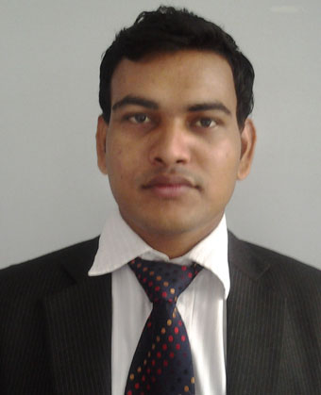
D-12, 3rd Floor, Suraj Appartment,
Block-A, New Town, Rajrahat,
Above HDFC Bank, Kolkata-700102.
Mobile No: +919778226136
Email id : rakeshsahoo89@gmail.com

OBJECTIVE

Seeking a challenging position in a Growing organization which provides opportunities for professional growth and To Utilize my Managerial, Technical Skills & Knowledge and at the same time I will learn new skills and grow with the company in the field of Marketing/IT Operation.

PROFILE
- Self motivated, COMMITMED TOWARDS ENTERPRISE goal
- POSSES strong analytical and interpersonal skills .
- Good communication skills, ( verbal as well as written coupled with presentation skills.)

PROFESSIONAL EXPERIENCE
NAME OF THE COMPANY- EXQUISITE PRINT & PACK PVT. LTD.
Experience- August 2016-Till Continue
Designation- Marketing Executive
Key Responsibility Client Operation, Arrange Meeting, Meet Client, Know about the client's requirement,Client handling, Make Quotation, Converting to Order.

NAME OF THE COMPNY- NEXTGEN PRINTERS PVT LTD.
Experience- July 2015-July 2016
Designation- Marketing Executive
Key Responsibility- Total Client Operation, Arrange Meeting, Meet Client, Know about the client's requirement, Make Quotation, Client handling, Converting to Order.
Operate RENUKA Software-Customer Relationship Management (CRM), Sales Order.

NAME OF THE COMPANY- WEB SOCIETY PVT LTD.
Experience-January 2015 to April 2015
Designation-Marketing Executive
Key Responsibility-Meet Client, Understanding Clients Requirements, Pitch about the product in front of Clients & Decide Pricing.

NAME OF COMPANY- ICRA LIMITED.
Experience- June 2014 to December 2014
Designation- Business Associate
Key Responsibility- Meet Bankers, Maintain Good Relationship with Bankers, Collect all Information about Client, Call Client, Arrange Meeting, Meet Client, Convincing Client, Sell our Services.
EDUCATIONAL QUALIFICATION

QUALIFICATION | BOARD/UNIVERSITY | INSTITUTION | YEAR OF PASSING
Master of Business Administration | Mahatma Gandhi University | Indian Institute of Planning & Management | 2014
Bachelor of Technology | Biju Pattanaik University of Technology | Synergy Institute of Engineering & Technology, Dhenkanal | 2011
Intermediate | Council of Higher Secondary Education | Prasanna Purusottam Dev Mahavidyalaya,Tigiria | 2006
Matric | High School Certificate Examination | Bidi Shramika Bidyaniketan,Somapada | 2004
COMPUTER SKILLS
Languages : C, C++, HTML, JAVA.
Operating systems : Windows 98/2000/XP,MS Office 2010.
Database : Data structures, RDBMS.

PROJECT
Name :ONLINE SESSIONAL EXAM FOR COLLEGE
Tools Used :Apache® Tomcat® , PHP AND JavaScript MySQL
Role :Database management

SUMMER INTERNSHIP
Title :Market Research & Sales
Company : LG Electronics Pvt Ltd.
Key Responsibility : Conducting Market Research in Market
Duration : November 2012 to January 2013

Learning outcomes:

1. Lead generation techniques
2. Presentation skill
3. Negotiation skill
4. Marketing processes

EXTRA CURRICULAR ACTIVITIES
ACTIVITY | COLLEGE | YEAR | ACHIEVEMENTS
SYNTECH | SIET,DKL | 2010-11 | ORGANISED
PERSONAL PROFILE

Date of Birth :16/06/1989
Languages Known :English, Hindi, Oriya, Bengali.
Hobbies :Listening to soft music, playing badminton, Surfing Internet .
Gender : Male
Permanent Address: At:- Chandipur Patana, Po:-Gholapur, Via:-Athagarh, Dist:-Cuttack
State:-Odisha, Pin : 754029

DECLARATION:

I here by declare that the above furnished details are true and correct to the best of my knowledge.

